1

SRI VENKATESWARA COLLEGE OF ENGINEERING

PENNALUR, SRIPERUMBUDUR

IT16301-COA

UNIT – 4 MEMORY AND I/O SYSTEMS (PART-I)

MEMORY HIERARCHY
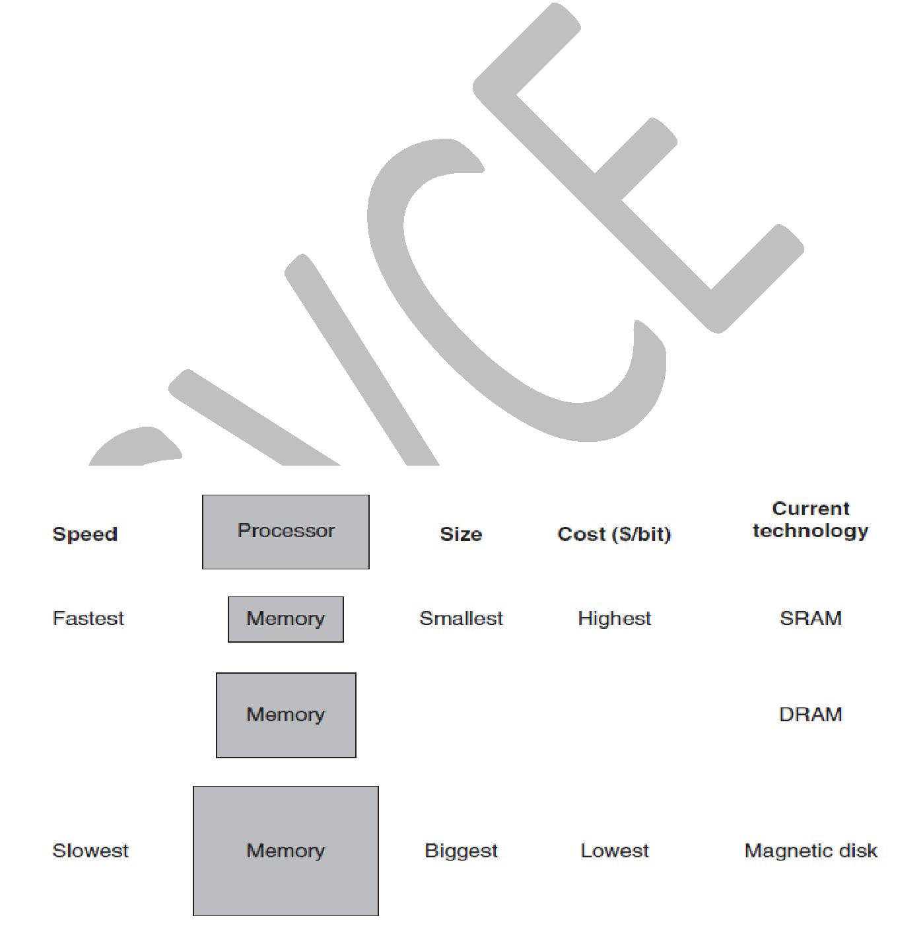

The principle of locality states that programs access a relatively small portion of their address space at any instant of time. Most of the programs do not access all code or data uniformly. There are two different types of locality:

- Temporal locality (locality in time):

If an item is referenced, it will tend to be referenced again soon. The principle stating that if a data location is referenced then it will tend to be referenced again soon.

- Spatial locality (locality in space):

If an item is referenced, items whose addresses are close by will tend to be referenced soon. The locality principle stating that if a data location is referenced, data locations with nearby addresses will tend to be referenced soon.

Memory Hierarchy Basic structure:

A structure that uses multiple levels of memories; as the distance from the processor increases, the size of the memories and the access time both increase. A memory hierarchy consists of multiple levels of memory with different speeds and sizes. The faster memories are more expensive per bit than the slower memories and thus are smaller.

2

A memory hierarchy can consist of multiple levels, but data is copied between only two adjacent levels at a time, so we can focus our attention on just two levels. The upper level—the one closer to the processor—is smaller and faster than the lower level, since the upper level uses technology that is more expensive.
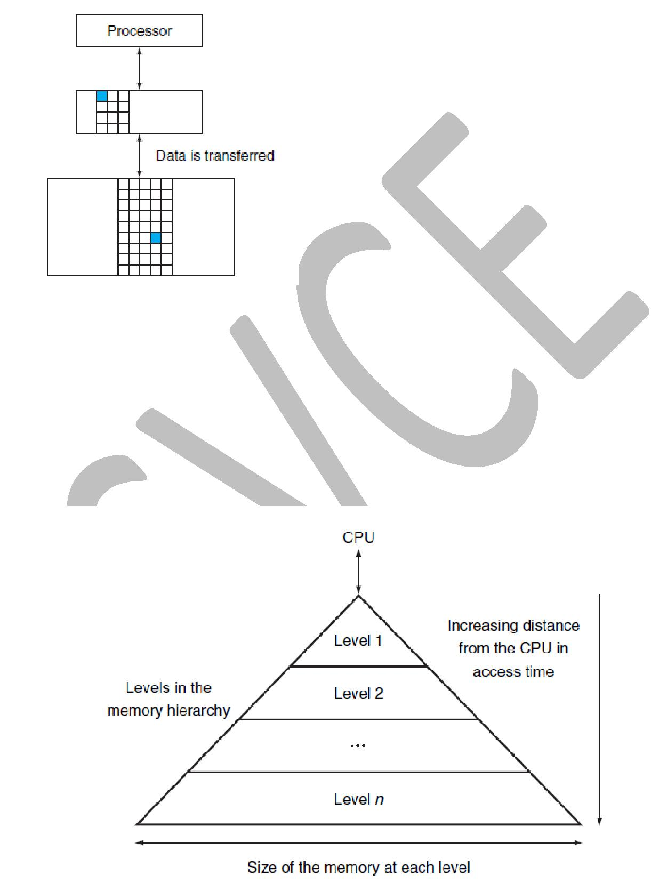

The above diagram shows the upper and lower level of memory with data blocks. Every pair of levels in the memory hierarchy can be thought of as having an upper and lower level. Within each level, the minimum unit of information that is present or not is called a block or a line. Usually we transfer an entire block when we copy something between levels.

The below diagram shows the structure of a memory hierarchy: as the distance from the processor increases, so does the size. This structure, with the appropriate operating mechanisms, allows the processor to have an access time that is determined primarily by level 1 of the hierarchy and yet have a memory as large as level n. Although the local disk is normally the bottom of the hierarchy, some systems use tape or a file server over a local area network as the next levels of the hierarchy.

3

Memory Access:

Hit rate – Hit memory access / Total memory access
The fraction of memory accesses found in a level of the memory hierarchy.

Miss rate – Miss memory access / Total memory access
The fraction of memory accesses not found in a level of the memory hierarchy.

Total memory access = Hit memory access + Miss memory access


Miss rate = 1 – hit rate

Hit time – time to determine if the access is indeed a hit + time to access and deliver the data from the upper level to the CPU

Miss penalty - time to determine if the access is a miss + time to replace block at upper level with corresponding block at lower level + time to deliver the block to the CPU

MEMORY TECHNOLOGIES

The various memory technologies used in building memory hierarchies are:
- SRAM semiconductor memory

- DRAM semiconductor memory
- Flash semiconductor memory
- Magnetic disk

SRAM:
- Static random access memory

- Volatile – loses data when there is no power
- Used to make caches

- Very fast
- Very costly

DRAM
- Dynamic random access memory
- Volatile – loses data when there is no power
- Used to make main memory

- Slower than SRAM
- Cheaper than SRAM

Main memory is implemented from DRAM (dynamic random access memory), while levels closer to the processor (caches) use SRAM (static random access memory). DRAM is less costly per bit than SRAM, although it is substantially slower. The price difference arises because DRAM uses significantly less area per bit of memory, and DRAMs thus have larger capacity for the same amount of silicon.

The below table highlights the difference between SRAM and DRAM:

4
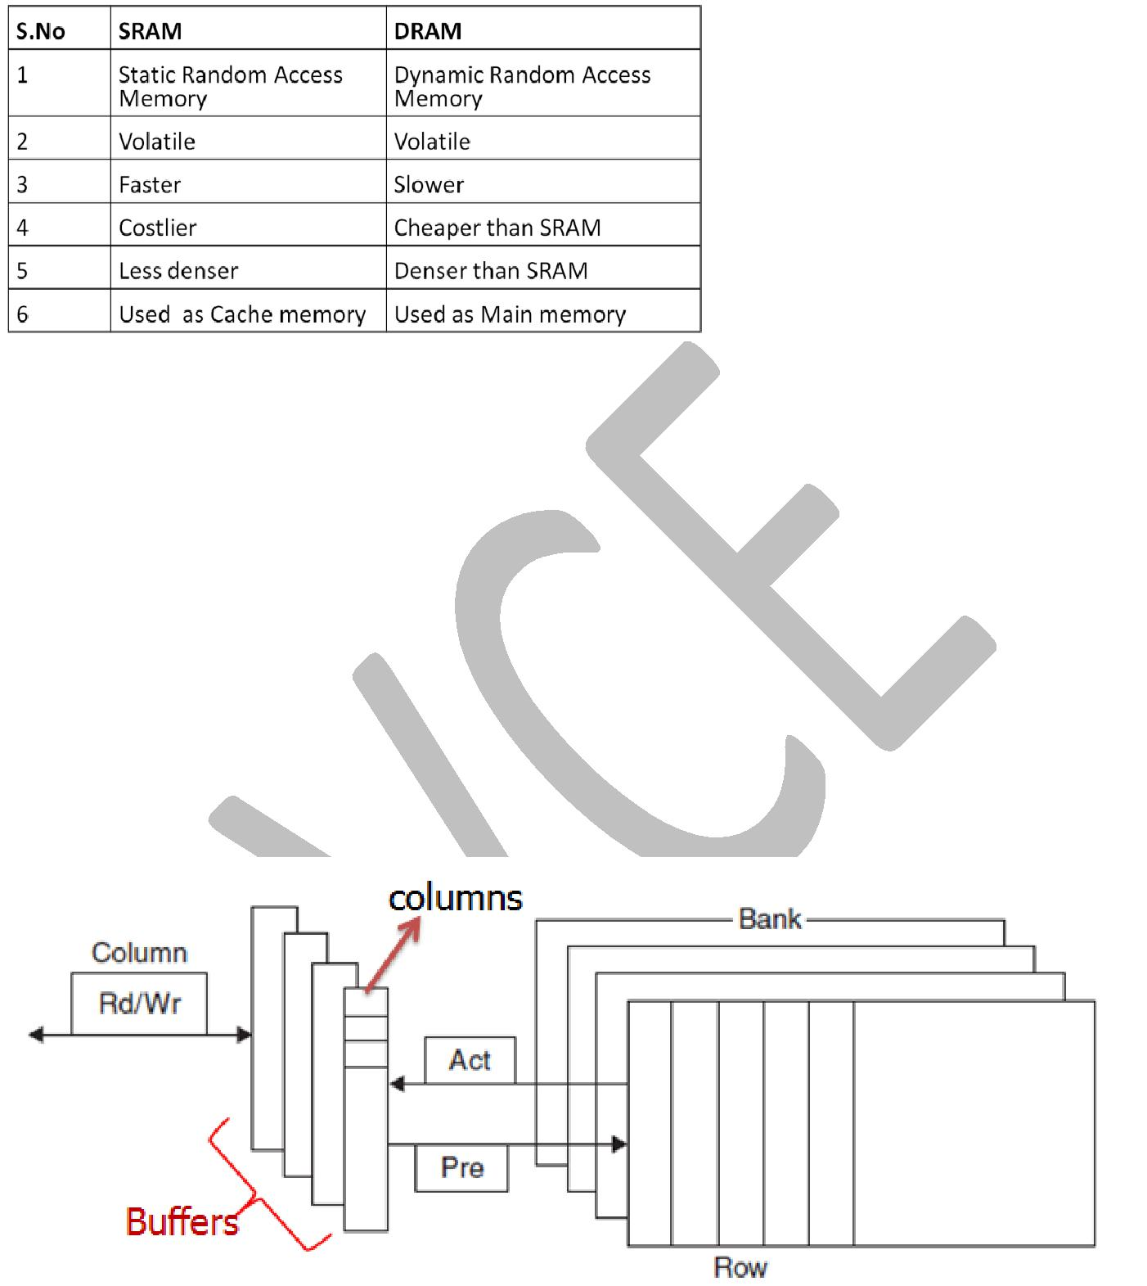

Difference between SRAM and DRAM:

SRAMs are simply integrated circuits that are memory arrays with a single access port that can provide either a read or a write. SRAMs have a fixed access time to any datum. SRAMs don’t need to refresh and so the access time is very close to the cycle time. SRAMs typically use six to eight transistors per bit to prevent the information from being disturbed when read. SRAM needs only minimal power to retain the charge in standby mode.

In a dynamic RAM (DRAM), the value kept in a cell is stored as a charge in a capacitor. A single transistor is then used to access this stored charge, either to read the value or to overwrite the charge stored there. Because DRAMs use only a single transistor per bit of storage, they are much denser and cheaper per bit than SRAM. As DRAMs store the charge on a capacitor, it cannot be kept indefinitely and must periodically be refreshed.

Internal Organization of DRAM:

Modern DRAMs are organized in banks, typically four. Each bank consists of a series of rows. Sending a PRE (precharge) command opens or closes a bank. A row address is sent with an Act (activate), which causes the row to transfer to a buffer. When the row is in the buffer, it can be transferred by successive column addresses at whatever the width of the DRAM is (typically 4, 8, or 16 bits) or by specifying a block transfer and the starting address.

5

Each DRAM has 4 banks. Each bank has many rows.

Command:
Pre – Precharge command – opens/close a bank

Act – Activate command – transfer row from bank to buffer
Each buffer has many columns.

Command:
Rd – Read command – read data from buffer column

Wr – Write command – write data to buffer column

DDR – Double Data Rate

Data is transferred during both rising and falling edge of the clock. (20 + 20 = 40Mbps) So we can achieve double data rate in single clock cycle itself.
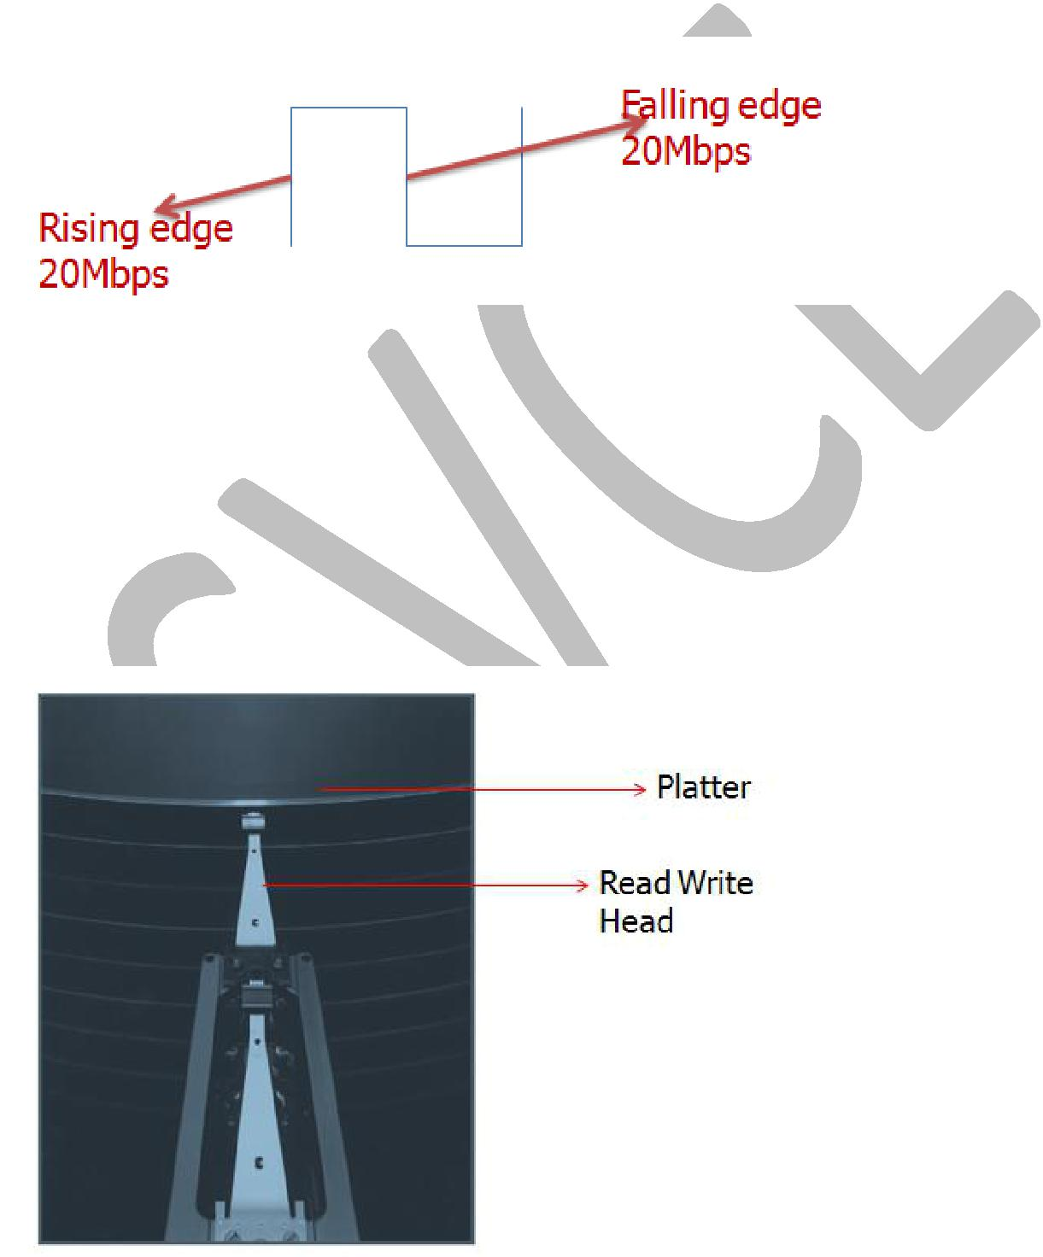

Flash Memory:

Flash memory is a type of electrically erasable programmable read-only memory (EEPROM). Disadvantage: EEPROM technologies can wear out flash memory bits. Solution: (wear levelling), flash products has a controller to spread the writes by remapping blocks that have been written many times to less trodden blocks. This technique is called wear leveling.

Magnetic disk:

The fourth technology, used to implement the largest and slowest level in the hierarchy, is usually magnetic disk.

6

Magnetic disk components:

- Read-write head - To read and write information on a hard disk, a movable arm containing a small electromagnetic coil called a read-write head is located just above each surface.

- Track - One of thousands of concentric circles that makes up the surface of a magnetic disk.

- Sector - One of the segments that make up a track on a magnetic disk; a sector is the smallest amount of information that is read or written on a disk.

- seek - The process of positioning a read/write head over the proper track on a disk
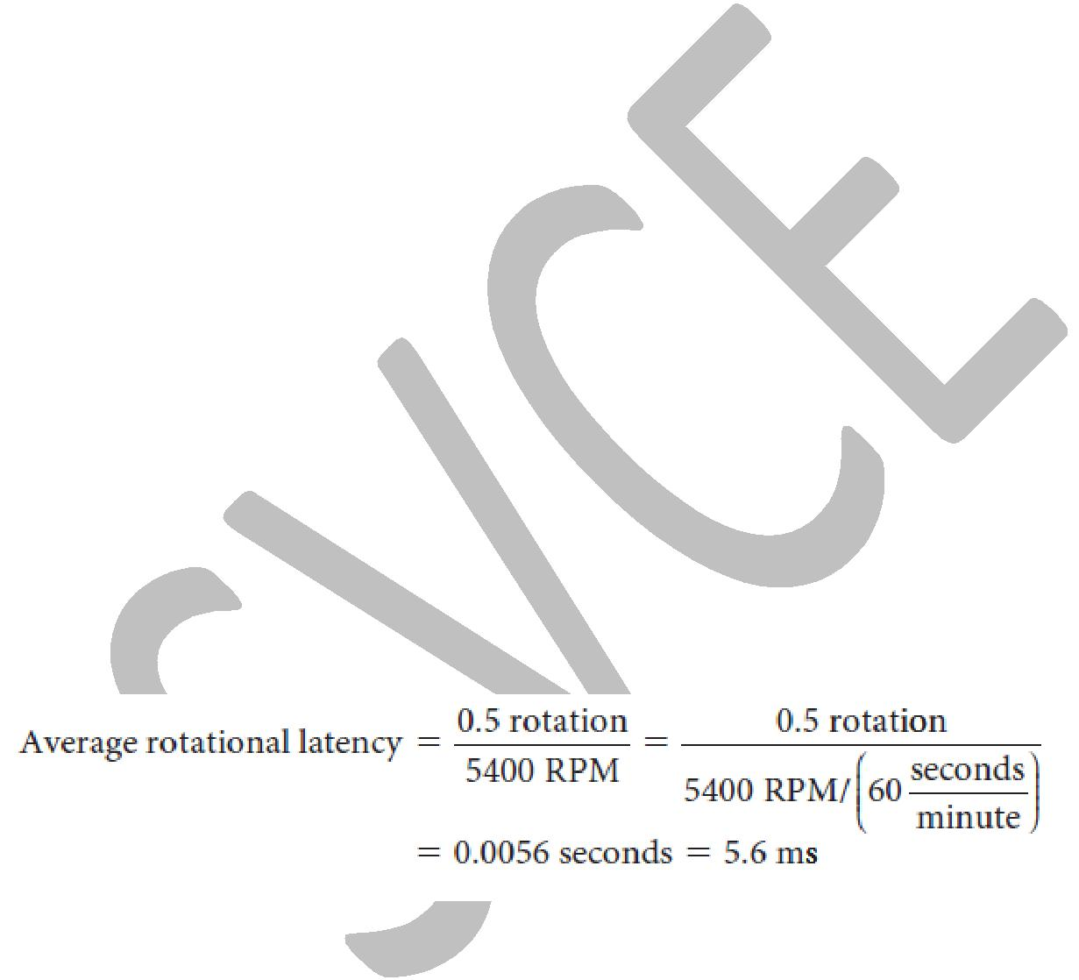

3 computational times:

- Seek time - the time to move the head to the desired track.

- Rotational latency – Also called rotational delay. The time required for the desired sector of a disk to rotate under the read/write head; usually assumed to be half the rotation time.

- Transfer time - is the time to transfer a block of bits. The transfer time is a function of the sector size, the rotation speed, and the recording density of a track. Transfer rates in 2012 were between 100 and 200 MB/sec.

The average latency to the desired information is halfway around the disk. Disks rotate at 5400 RPM to 15,000 RPM. The average rotational latency at 5400 RPM is,

The access time and price per bit vary widely among these technologies, as the table below shows
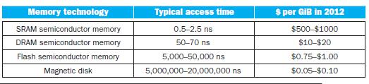

7

THE BASICS OF CACHES

The term cache is used to refer to any storage managed to take advantage of locality of access.

Definitions:

Block (or line) - The minimum unit of information that can be either present or not present in a cache.

Cache Hit - If the data requested by the processor appears in some block in the upper level, this is called a hit.

Cache Miss - If the data is not found in the upper level, the request is called a miss. The lower level in the hierarchy is then accessed to retrieve the block containing the requested data.
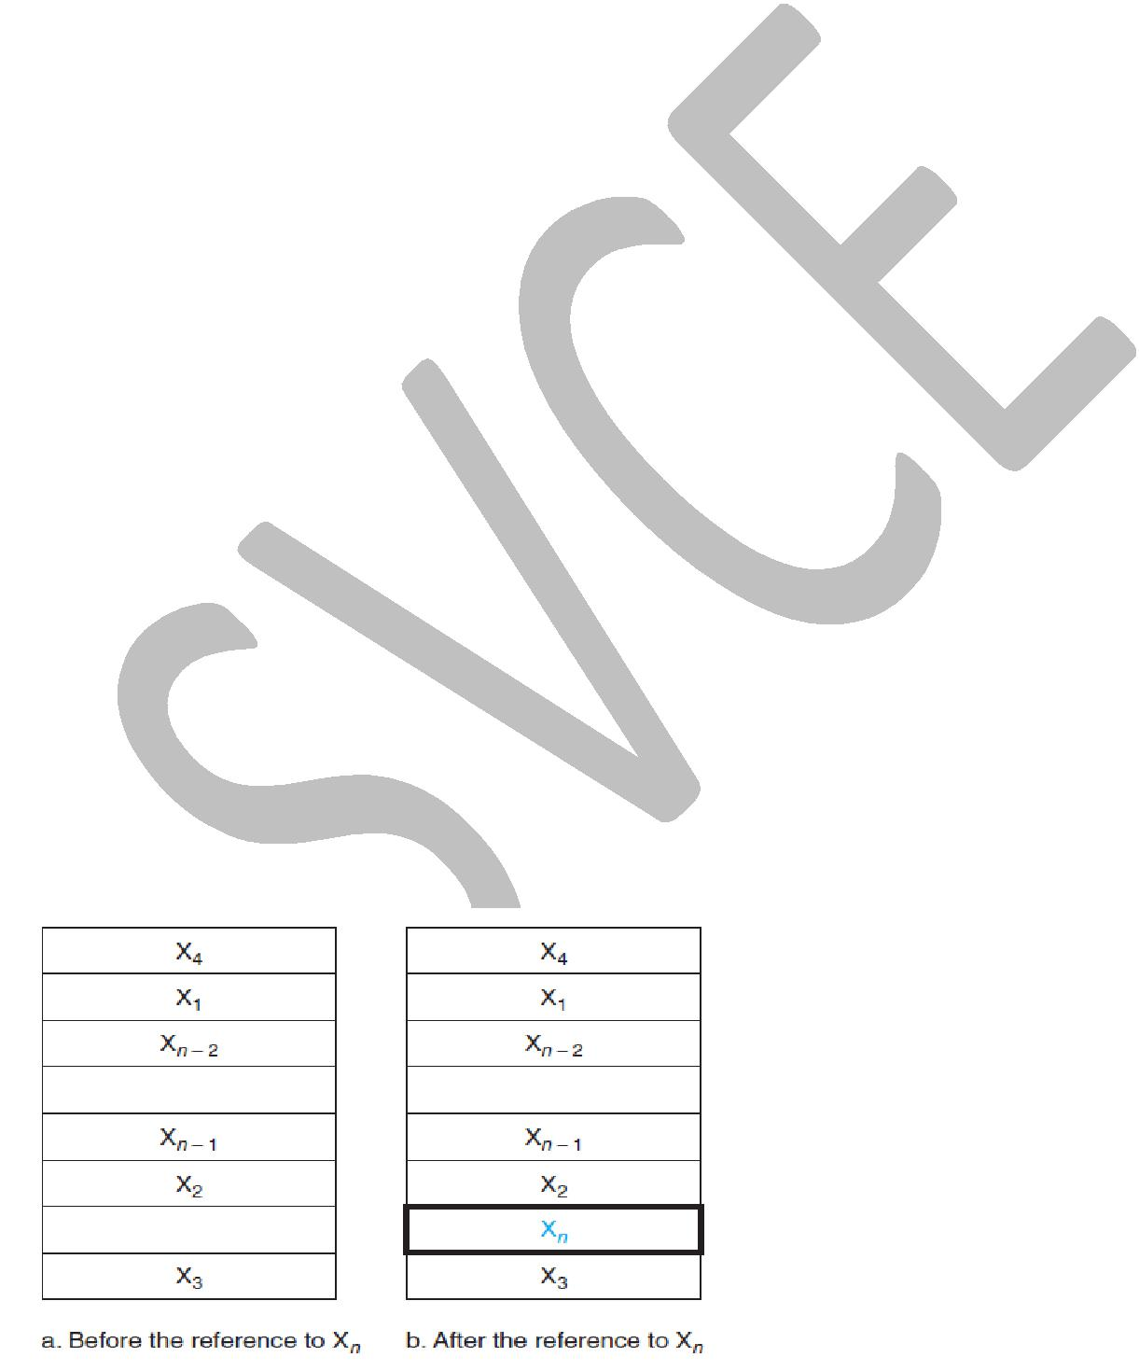

The hit rate, or hit ratio, is the fraction of memory accesses found in the upper level; it is often used as a measure of the performance of the memory hierarchy.

The miss rate is the fraction of memory accesses not found in the upper level.

Miss rate = 1 - hit rate

Hit time is the time to access the upper level of the memory hierarchy, which includes the time needed to determine whether the access is a hit or a miss.

The miss penalty is the time to replace a block in the upper level with the corresponding block from the lower level, plus the time to deliver this block to the processor. Because the upper level is smaller and built using faster memory parts, the hit time will be much smaller than the time to access the next level in the hierarchy, which is the major component of the miss penalty.

Miss penalty is defined as the time required to fetch a block into a level of the memory hierarchy from the lower level, including the time to access the block, transmit it from one level to the other, insert it in the level that experienced the miss, and then pass the block to the requestor.

Consider a simple cache in which the processor requests are one word at a time and the blocks also consist of a single word.

8

Before the request, the cache contains a collection of recent references X1, X2, . . . , Xn-1, and the processor requests a word Xn that is not in the cache. This request results in a miss, and the word Xn is brought from memory into the cache.

Two questions are considered here:

- How do we know if a data item is in the cache?

- If it is, how do we find it?

These questions are answered by the 3 mapping techniques.

3 CACHE MAPPING TECHNIQUES
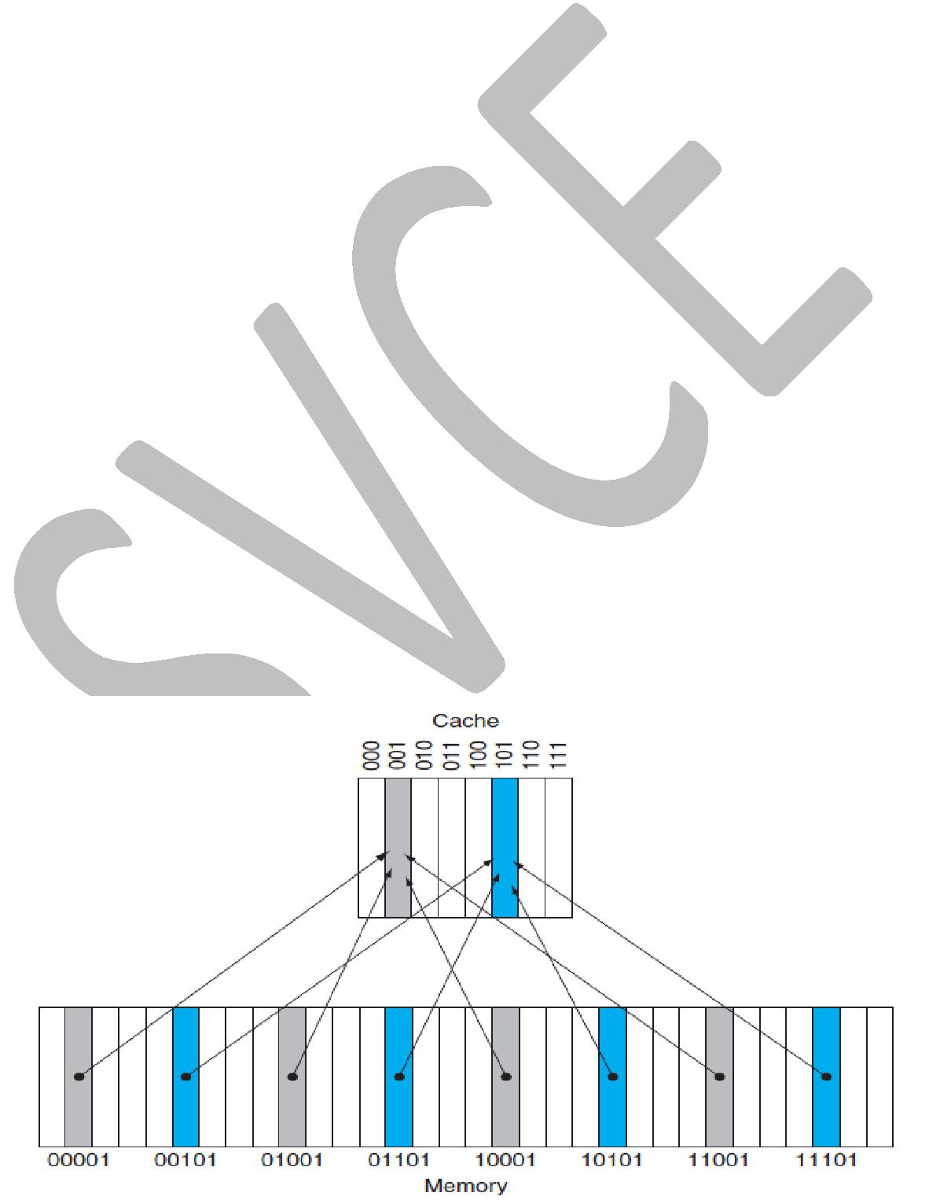

- Direct mapped cache

- Set associative cache

- Fully associative cache

- Direct mapped cache:

Direct-mapped cache - A cache structure in which each memory location is mapped to exactly one location in the cache.

If each word can go in exactly one place in the cache, then it is straightforward to find the word if it is in the cache. The simplest way to assign a location in the cache for each word in memory is to assign the cache location based on the address of the word in memory. This cache structure is called direct mapped, since each memory location is mapped directly to exactly one location in the cache.

The typical mapping between addresses and cache locations for a direct-mapped cache is usually simple. For example, almost all direct-mapped caches use this mapping to find a block:

(Block address) modulo (Number of blocks in the cache)

The below diagram shows a direct-mapped cache with eight entries showing the addresses of memory words between 0 and 31 that map to the same cache locations

The number of blocks in the cache is a power of 2. In below diagram, there are 8-blocks in the cache then the address of each block is given by (8 = 2³) 3 bits.

9

Because each cache location can contain the contents of a number of different memory locations,

- How do we know whether the data in the cache corresponds to a requested word? That is, how do we know whether a requested word is in the cache or not?

We answer this question by adding a set of tags to the cache.

The tags contain the address information required to identify whether a word in the cache corresponds to the requested word. The tag needs only to contain the upper portion of the address, corresponding to the bits that are not used as an index into the cache. In the example diagram above, we need only have the upper 2 of the 5 address bits in the tag, since the lower 3-bit index field of the address selects the block.

Ex: In 00101 – memory address; 00 is the tag and 101 is the cache block address (i.e.

index).

Valid bit: We also need to recognize that a cache block does not have valid information. For instance, when a processor starts up, the cache does not have good data, and the tag fields will be meaningless. Even after executing many instructions, some of the cache entries may still be empty, as in the above figure. Thus, we need to know that the tag should be ignored for such entries. The most common method is to add a valid bit to indicate whether an entry contains a valid address. If the bit is not set (0), then the cache block does not have valid data. If the bit is set (1), then the cache block has valid data.

Definition:

Tag - A field in a table used for a memory hierarchy that contains the address information required to identify whether the associated block in the hierarchy corresponds to a requested word.

Valid bit - A field in the tables of a memory hierarchy that indicates that the associated block in the hierarchy contains valid data.

ACCESSING A CACHE:

Below is a sequence of nine memory references to an empty eight-block cache, including the action for each reference. There are eight blocks in the cache, the low-order three bits of an address give the block number.

10
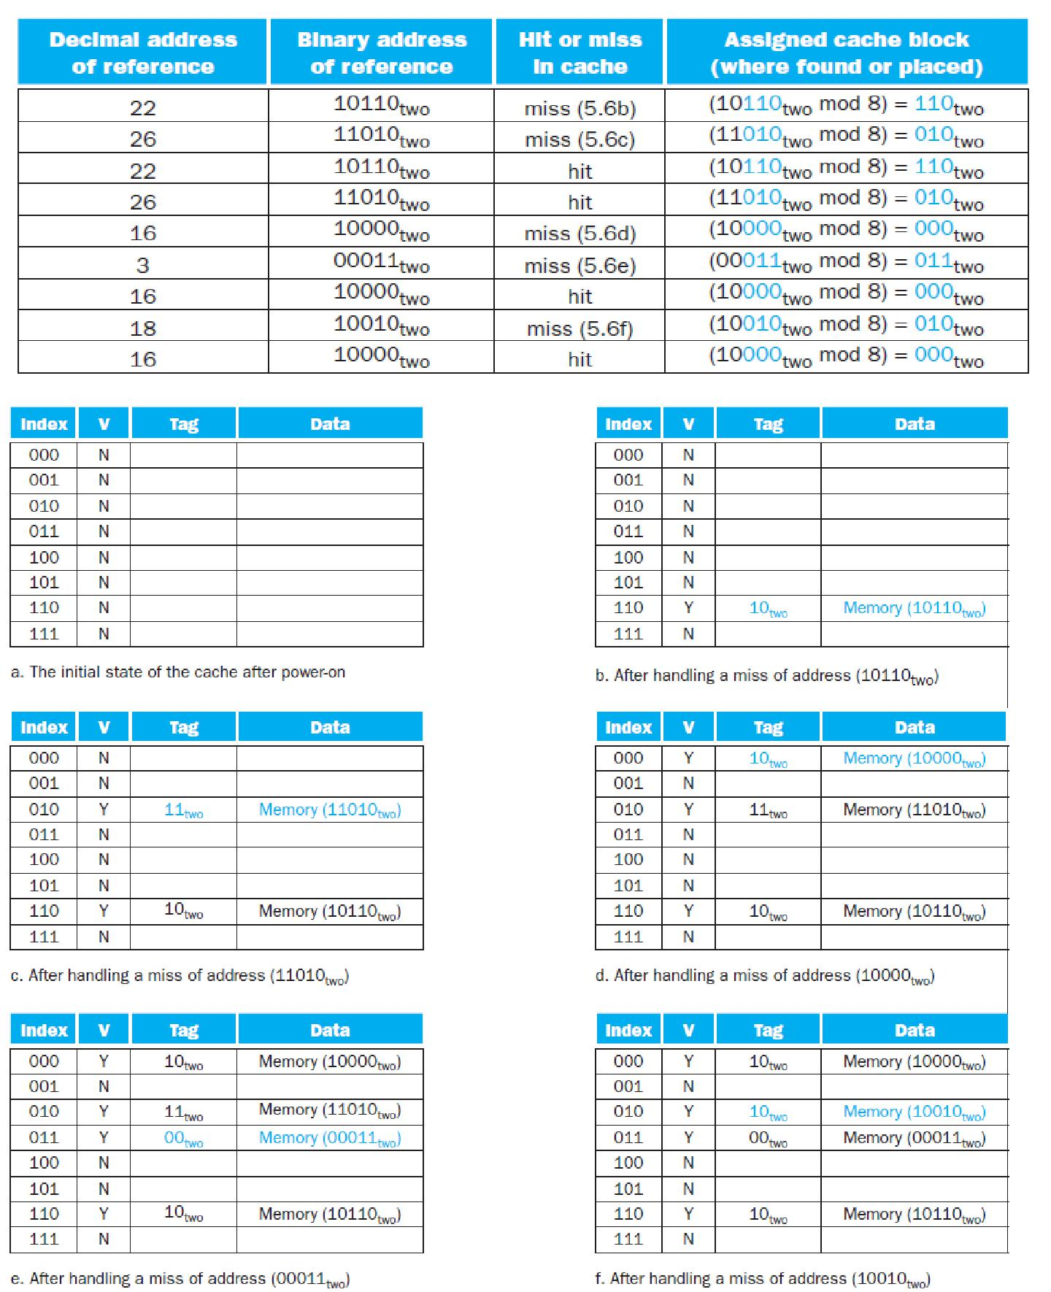

The above diagram shows the contents of cache for each memory reference as given in the above table. Since the cache is empty, several of the first references are misses. On the eighth reference we have conflicting demands for a block. The word at address 18 (10010two) should be brought into cache block 2 (010two). Hence, it must replace the word at address 26

11

(11010two), which is already in cache block 2 (010two). This behavior allows a cache to take advantage of temporal locality: recently referenced words replace less recently referenced words. (LRU – least recently used)

In a direct-mapped cache, there is only one place to put the newly requested item and hence only one choice of what to replace. The low-order bits of an address can be used to find the unique cache entry to which the address could map.
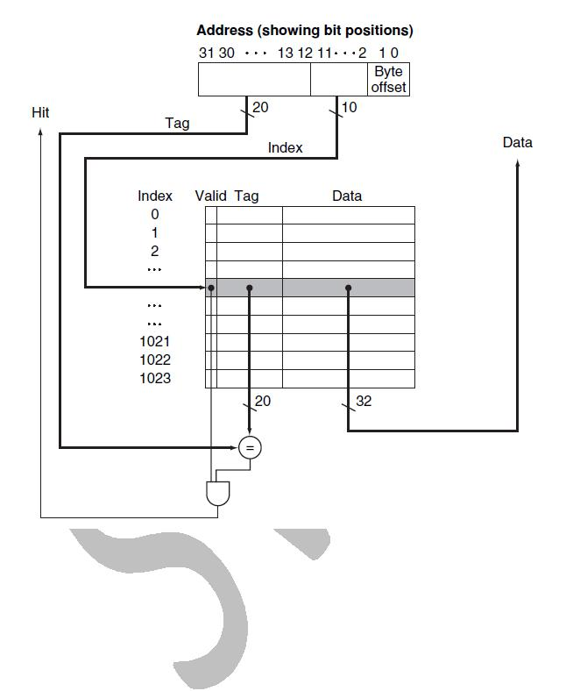

The above Figure shows how a referenced address is divided into

- A tag field, which is used to compare with the value of the tag field of the cache
- A cache index, which is used to select the cache block

The index of a cache block, together with the tag contents of that block, uniquely specifies the memory address of the word contained in the cache block.

In the MIPS architecture, since words are of four bytes in size, the least significant two bits of every address specify a byte within a word. Hence, the least significant two bits are ignored when selecting a word in the block.

12

The total number of bits needed for a cache is a function of the cache size and the address size, because the cache includes both the storage for the data and the tags. The size of the block above was one word, but normally it is several.

For the following situation:
■32-bit byte addresses
- A direct-mapped cache
- The cache size is 2^{n} blocks, so n bits are used for the index
- The block size is 2^{m} words (2^{m+2} bytes or 2^{m+5}bits ), so m bits are used for the word within the
block, and two bits are used for the byte part of the address the size of the tag field is

Tag size = 32 - (n + m + 2)

The total number of bits in a direct-mapped cache 2^{n} ×(block size + tag size + valid field size).

valid field size = 1

Since the block size is 2^{m} words (2^{m+5} bits), and we need 1 bit for the valid field, the number of bits in such a cache is

2^{n} × (2^{m} ×32 + (32 - n - m - 2) + 1) = 2^{n} × (2^{m} × 32 + 31 - n - m)

PROBLEM

- How many total bits are required for a direct-mapped cache with 16 KB of data and 4-word blocks, assuming a 32-bit address?

Answer

Cache data = 16 KB = 2¹⁴ bytes = 2¹² words = 2¹² words / 4 words = 2¹⁰ blocks Each cache entry size = block data bits + tag bits + valid bit

- (4*32) + (32 – 10 – 2 - 2) + 1 = 128 + 18 + 1 = 147 bits Therefore, Entire cache size = 2¹⁰ × 147 bits = 2¹⁰ × (147) bits = 147 Kbits Total cache size -> 147Kbits / 8 = 18.4 Kbytes
Actual cache size (only data) -> 16Kbytes

Total cache size/Actual cache data = 18.4/16 = 1.15

So 15% increase in the cache size to include tag and valid bits.

13

PROBLEM

How many total bits are required for a direct-mapped cache with 128 KB of data and 1-word block size, assuming a 32-bit address?

Cache data = 128 KB = 2¹⁷ bytes = 2¹⁵ words = 2¹⁵ blocks Cache entry size = block data bits + tag bits + valid bit
= 32 + (32 – 15 – 2) + 1 = 48 bits

Therefore, cache size = 2¹⁵ × 48 bits = 2¹⁵ × (1.5 × 32) bits = 1.5 × 2²⁰ bits = 1.5 Mbits data bits in cache = 128 KB × 8 = 1 Mbits

total cache size/actual cache data = 1.5

PROBLEM

How many total bits are required for a direct-mapped cache with 128 KB of data and 4-word block size, assuming a 32-bit address?

Cache size = 128 KB = 2¹⁷ bytes = 2¹⁵ words = 2¹³ blocks Cache entry size = block data bits + tag bits + valid bit
= 128 + (32 – 13 – 2 – 2) + 1 = 144 bits

Therefore, cache size = 2¹³ × 144 bits = 2¹³ × (1.25 × 128) bits = 1.25 × 2²⁰ bits = 1.25 Mbits Data bits in cache = 128 KB × 8 = 1 Mbits

Total cache size/actual cache data = 1.25

- Mapping an Address to a Multiword Cache Block

Consider a cache with 64 blocks and a block size of 16 bytes. To what block number does byte address 1200 map?

Use the formula:

(Block address) modulo (Number of blocks in the cache)

Block address = byte address/ bytes per block

- 1200 / 16 = 75

75 modulo 64 = 11th block in cache

14

MISS RATE VERSUS BLOCK SIZE.

Usually increasing the block size will decreases the miss rate. The miss rate may go up eventually if the block size becomes a significant fraction of the cache size, because the number of blocks that can be held in the cache will become small, and there will be a great deal of competition for those blocks. As a result, a block will be bumped out of the cache before many of its words are accessed.

Increasing the block size will make a problem of increase in the cost of a miss. The miss penalty is determined by the time required to fetch the block from the next lower level of the hierarchy and load it into the cache.
The time to fetch the block has two parts:
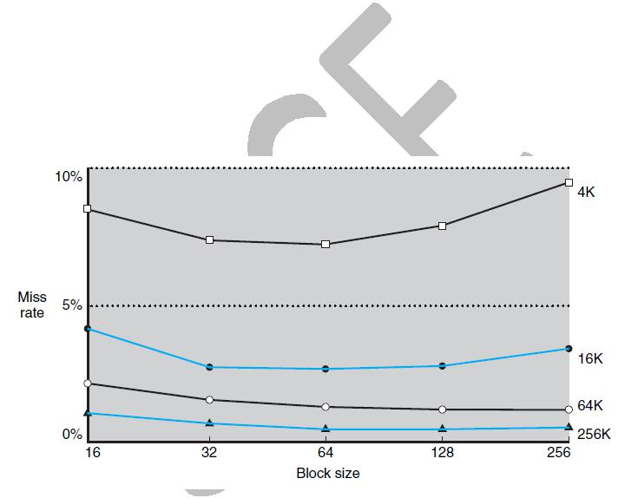
- Latency to the first word and

- Transfer time for the rest of the block.

The miss penalty will increase as the block size increases. Furthermore, the improvement in the miss rate starts to decrease as the blocks become larger. The result is that the increase in the miss penalty overwhelms the decrease in the miss rate for blocks that are too large, and cache performance thus decreases.

The above graph shows the Miss rate versus block size. Note that the miss rate actually goes up if the block size is too large relative to the cache size. Each line represents a cache of different size.

15

HANDLING CACHE MISSES:

Cache read hit: no action needed

Cache read miss:

Cache Miss - A request for data from the cache that cannot be filled because the data is not present in the cache.

The steps to be taken on an instruction cache miss:

- Send the original PC value (current PC – 4) to the memory.
- Instruct main memory to perform a read and wait for the memory to complete its access.

- Write the cache entry, putting the data from memory in the data portion of the entry, writing the upper bits of the address into the tag field, and turning the valid bit on.

- Restart the instruction execution at the first step, which will refetch the instruction, this time finding it in the cache. (cache hit)

If an instruction access results in a miss, then the content of the Instruction register is invalid. To get the proper instruction into the cache, we must be able to instruct the lower level in the memory hierarchy to perform a read. Since the program counter is incremented in the first clock cycle of execution, the address of the instruction that generates an instruction cache miss is equal to the value of the program counter minus 4. Once we have the address, we need to instruct the main memory to perform a read. We wait for the memory to respond and then write the words containing the desired instruction into the cache.

The control unit must detect a miss and process the miss by fetching the requested data from memory. If the cache reports a hit, the computer continues using the data as if nothing happened. The cache miss handling is done in collaboration with the processor control unit and with a separate controller that initiates the memory access and refills the cache. The processing of a cache miss creates a pipeline stall as opposed to an interrupt, which would require saving the state of all registers. For a cache miss, we can stall the entire processor, essentially freezing the contents of the temporary and programmer-visible registers, while we wait for memory.

HANDLING WRITES

Suppose on a store instruction, we wrote the data into only the data cache (without changing main memory); then, after the write into the cache, memory would have a different value from that in the cache.

In such a case, the cache and memory are said to be inconsistent.

There are two schemes are used to keep the main memory and the cache consistent. They are

- write-through
- write-back

16

Write-through:

This scheme writes the data always into both the memory and the cache. It is a scheme in which writes always update both the cache and the next lower level of the memory hierarchy, ensuring that data is always consistent between the two.

With a write-through scheme, every write causes the data to be written to main memory. These writes will take a long time, likely at least 100 processor clock cycles, and could slow down the processor considerably. For example, suppose 10% of the instructions are stores. If the CPI without cache misses was 1.0, spending 100 extra cycles on every write would lead to a CPI of 1.0 + 100 ×10% = 11, reducing performance by more than a factor of 10.

Disadvantage of write-through – performance is slow. This is improved through write buffer. Write buffer is a queue that holds data while the data is waiting to be written to memory.

A write buffer stores the data while it is waiting to be written to memory. After writing the data into the cache and into the write buffer, the processor can continue execution. When a write to main memory completes, the entry in the write buffer is freed. If the write buffer is full when the processor reaches a write, the processor must stall until there is an empty position in the write buffer.

Write-back (copy back):

It is a scheme that handles writes by updating values only to the block in the cache, then writing the modified block to the lower level of the hierarchy when the block is replaced.

In a write-back scheme, when a write occurs, the new value is written only to the block in the cache. The modified block is written to the lower level of the hierarchy when it is replaced. Advantage: Write-back schemes have improved performance over write-through scheme. Disadvantage: Write-back scheme is more complex to implement than write-through.

MEASURING AND IMPROVING CACHE PERFORMANCE:

Two different techniques for improving cache performance:

- Reducing the miss rate by reducing the probability that two different memory blocks will contend for the same cache location.

- The second technique reduces the miss penalty by adding an additional level to the hierarchy. This technique, called multilevel caching.

CPU Time:

CPU time can be divided into the clock cycles that the CPU spends executing the program and the clock cycles that the CPU spends waiting for the memory system. Normally, we assume that the costs of cache accesses that are hits are part of the normal CPU execution cycles.

17

Simplified model assuming equal read and write miss penalties:

CPU time = (execution cycles + memory stall cycles) x cycle time

Where,
Memory-stall clock cycles can be defined as the sum of the stall cycles coming from reads plus
those from writes.
Memory stall cycles = reads stall cycles + write stall cycles

The read-stall cycles can be defined in terms of the number of read accesses per program, the miss penalty in clock cycles for a read, and the read miss rate:
Read stall cycles = reads/program + read miss rate + read miss penalty

Write-stall cycles:
Write stall cycles = writes/program + write miss rate + write miss penalty

We can combine the reads and writes by using a single miss rate and the miss penalty in memory stall clock cycles.

Memory stall cycles = memory accesses/program x miss rate x miss penalty Memory stall cycles = instructions/program x miss/instruction x miss penalty

Where, memory accesses = read memory access + write memory access miss rate = read miss rate + write miss rate

miss penalty = read miss penalty = write miss penalty

PROBLEM

Calculating Cache Performance:

Question:

Assume the miss rate of an instruction cache is 2% and the miss rate of the data cache is 4%. If a processor has a CPI of 2 without any memory stalls and

the miss penalty is 100 cycles for all misses, determine how much faster a processor would run with a perfect cache that never missed. Assume the frequency of all loads and stores is 36%.

Given:

– instruction cache miss rate 2%
– data cache miss rate 4%
– miss penalty always 100 cycles

– CPI of 2 without memory stalls
– frequency of load/stores 36% of instructions
- How much faster is a machine with a perfect cache that never misses?

- What happens if we speed up the machine by reducing its CPI to 1 without changing the clock rate?

18

Solution for 1:

Assume instruction count = I

Memory stall cycles = instructions/program x miss/instruction x miss penalty

Instruction miss cycles = I × 2% × 100 = 2.0 × I Data miss cycles = I × 36% × 4% × 100 = 1.44 × I

Total memory-stall cycles = Instruction miss cycles + Data miss cycles
= 2 × I + 1.44 × I = 3.44 × I

CPI _{memory stalls} = Basic CPI + memory stall CPI

= 2 + 3.44 = 5.44

CPU time = IC x CPI x clock cycles

CPU time with stalls = IC x CPI _{memory stalls} x clock cycles CPU time with perfect cache = IC x Basic CPI x clock cycles

CPU time with stalls / CPU time with perfect cache
- I x 5.44 x clock cycles/ I x 2 x clock cycles
- 5.44 / 2
- 2.72

Performance with a perfect cache is better by a factor of 2.72

Solution for 2:

CPI without stall = 1

CPI with stall = Basic CPI + memory stall CPI
- 1 + 3.44
- 4.44

CPU time with stalls / CPU time with perfect cache
- IC x CPI with stall x clock cycles / IC x Basic CPI x clock cycles

- CPI with stall / Basic CPI
- 4.44 / 1

Performance with a perfect cache is better by a factor of 4.44
Conclusion: with higher CPI cache misses “hurt more” than with lower CPI

19

AMAT - AVERAGE MEMORY ACCESS TIME

AMAT is the average time to access memory considering both hits and misses and the frequency of different accesses.

AMAT = Time for a hit + Miss rate x Miss penalty

PROBLEM:

Find the AMAT for a processor with a 1 ns clock cycle time, a miss penalty of 20 clock cycles, a miss rate of 0.05 misses per instruction, and a cache access time (including hit detection) of 1 clock cycle. Assume that the read and write miss penalties are the same and ignore other write stalls.

Solution:

AMAT = Time for a hit + Miss rate x Miss penalty
- 1 + 0.05 x 20
- 1 + 1
- 2 clock cycles

Or clock cycle time = 2 x 1ns = 2ns

REDUCING CACHE MISSES BY MORE FLEXIBLE PLACEMENT OF BLOCKS

1. Direct mapped cache:

Direct-mapped cache - A cache structure in which each memory location is mapped to exactly one location in the cache.

If each word can go in exactly one place in the cache, then it is straightforward to find the word if it is in the cache. The simplest way to assign a location in the cache for each word in memory is to assign the cache location based on the address of the word in memory. This cache structure is called direct mapped, since each memory location is mapped directly to exactly one location in the cache.

In a direct-mapped cache, the position of a memory block is given by

(Block number) modulo (Number of blocks in the cache)

Advantage: searching for a block in cache is easy.
Disadvantage: Only one block in cache to place the memory block.

2. Fully associative cache

Fully associative cache: A cache structure in which a block can be placed in any location in the cache.

20

To find a given block in a fully associative cache, all the entries in the cache must be searched because a block can be placed in any one. To make the search practical, it is done in parallel with a comparator associated with each cache entry.

In a fully associative cache, since memory block can be placed in any cache block there is no formula to find the cache block number for the given memory block.

Advantage: a block from main memory can be placed in any block in the cache.
Disadvantage: has to search the entire cache to find a block in cache.

3. Set associative cache
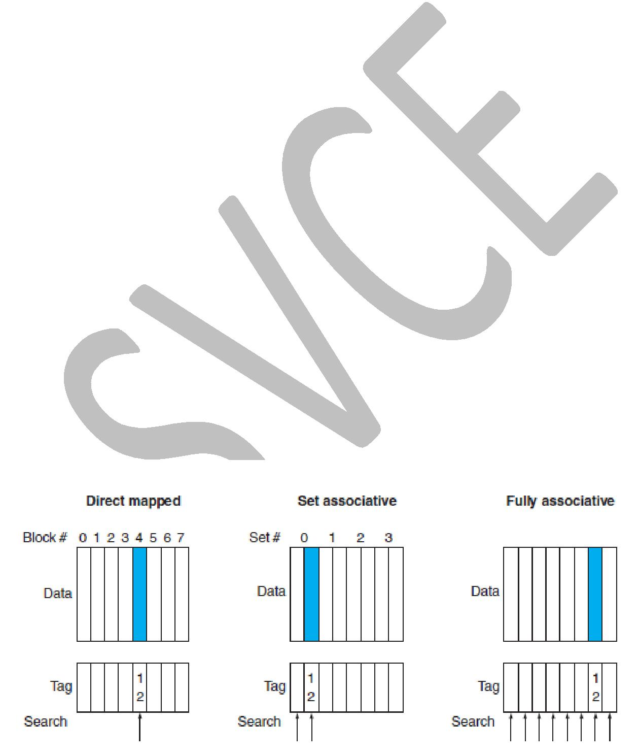

Set associative cache: A cache that has a fixed number of locations (at least two) where each block can be placed.

In a set-associative cache, there are a fixed number of locations where each block can be placed. A set-associative cache with n locations for a block is called an n-way set-associative cache. An n-way set-associative cache consists of a number of sets, each of which consists of n blocks. Each block in the memory maps to a unique set in the cache given by the index field, and a block can be placed in any element of that set. Thus, a set-associative placement combines direct-mapped placement and fully associative placement: a block is directly mapped into a set, and then all the blocks in the set are searched for a match.

Advantage: combines the advantage of both direct mapped cache and fully associative mapped cache.

- Easier to search
- More than one block to place the memory block in cache.

In a set-associative cache, the set containing a memory block is given by

(Block number) modulo (Number of sets in the cache)

For example, The following Figure shows where block 12 may be placed in a cache with eight blocks using direct, set-associative and fully associative mapping.

21

In direct mapped placement,
There is only one cache block where memory block 12 can be found,

(Block number) modulo (Number of blocks in the cache)

where, 12 – block number
8 – number of blocks in the cache

12 modulo 8 = 4

So, the 12th memory block is placed in 4th cache block using direct mapping cache policy.

In a two-way set-associative cache,

There would be four sets, and memory block 12 can be found in the set,

(Block number) modulo (Number of sets in the cache)
Where, 12 – block number

4 – sets in the cache, since 2 blocks per set.

12 mod 4 = 0

So, the 12th memory block could be in either element of the 0th set.

In a fully associative placement, the memory block for block address 12 can appear in any of the eight cache blocks.

Searching:

In set-associative cache, since the block may be placed in any element of the set, all the tags of all the elements of the set must be searched.

In a fully associative cache, the block can go anywhere, and all tags of all the blocks in the cache must be searched

The below figure shows an eight-block cache configured as direct mapped, two-way set associative, four-way set associative, and fully associative.

One-way set-associative:

The total size of the cache in blocks is equal to the number of sets. It is also equivalent to direct mapped cache.

Two-way set-associative:
Two blocks per set.

Four-way set-associative:
Four blocks per set.

Eight-way set-associative:
Eight blocks per set.

If the total cache block is eight, then an eight-way set-associative cache is the same as a fully associative cache.

22

Thus, for a fixed cache size, increasing the associativity decreases the number of sets while increasing the number of elements per set.
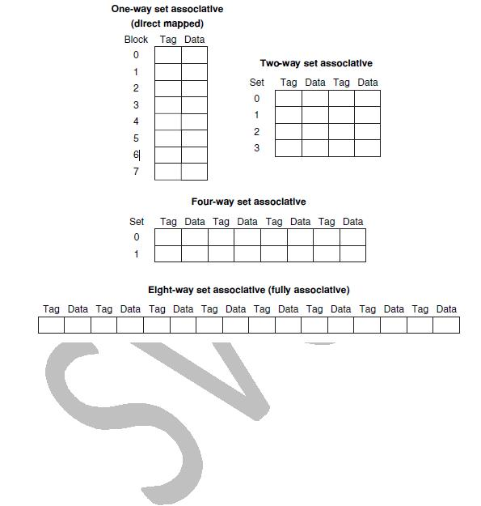

Misses and Associativity in Caches:

PROBLEM:

Find the number of misses for a cache with four 1-word blocks given the following sequence of memory block accesses: 0, 8, 0, 6, 8, for each of the following cache configurations

- direct mapped
- 2-way set associative (use LRU replacement policy)
- fully associative

Solution 1 (direct mapped):

Determine to which cache block each block address maps:
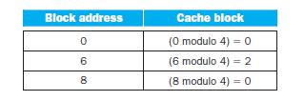

23

Now we can fill in the cache contents after each reference, using a blank entry to mean that the block is invalid, colored text to show a new entry added to the cache for the associated reference, and plain text to show an old entry in the cache:
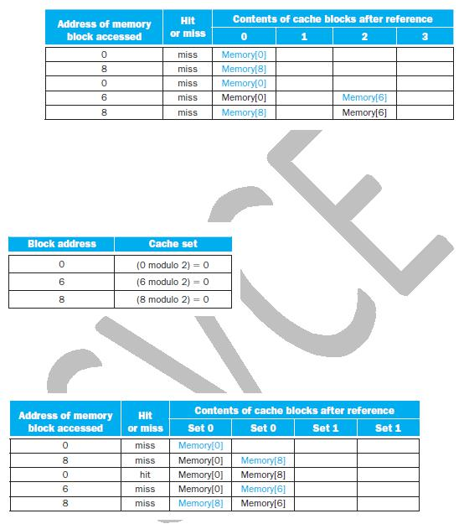

The direct-mapped cache generates five misses for the five accesses.

Solution 2 (2 way set associative):

The set-associative cache has two sets (with indices 0 and 1) with two elements per set. Let’s first determine to which set each block address maps:

Because we have a choice of which entry in a set to replace on a miss, we need a replacement rule. Set-associative caches usually replace the least recently used block within a set; that is, the block that was used furthest in the past is replaced. (LRU – Least Recently Used)

Using this replacement rule, the contents of the set-associative cache after each reference looks like this:

Notice that when block 6 is referenced, it replaces block 8, since block 8 has been less recently referenced than block 0. The two-way set-associative cache has four misses, one less than the direct-mapped cache.

Solution 3 (fully associative):

The fully associative cache has four cache blocks (in a single set); any memory block can be stored in any cache block. The fully associative cache has the best performance, with only three misses:

24
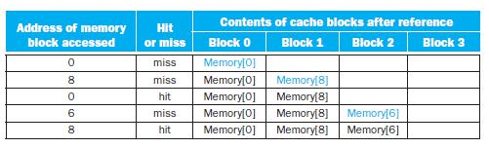

Conclusion:
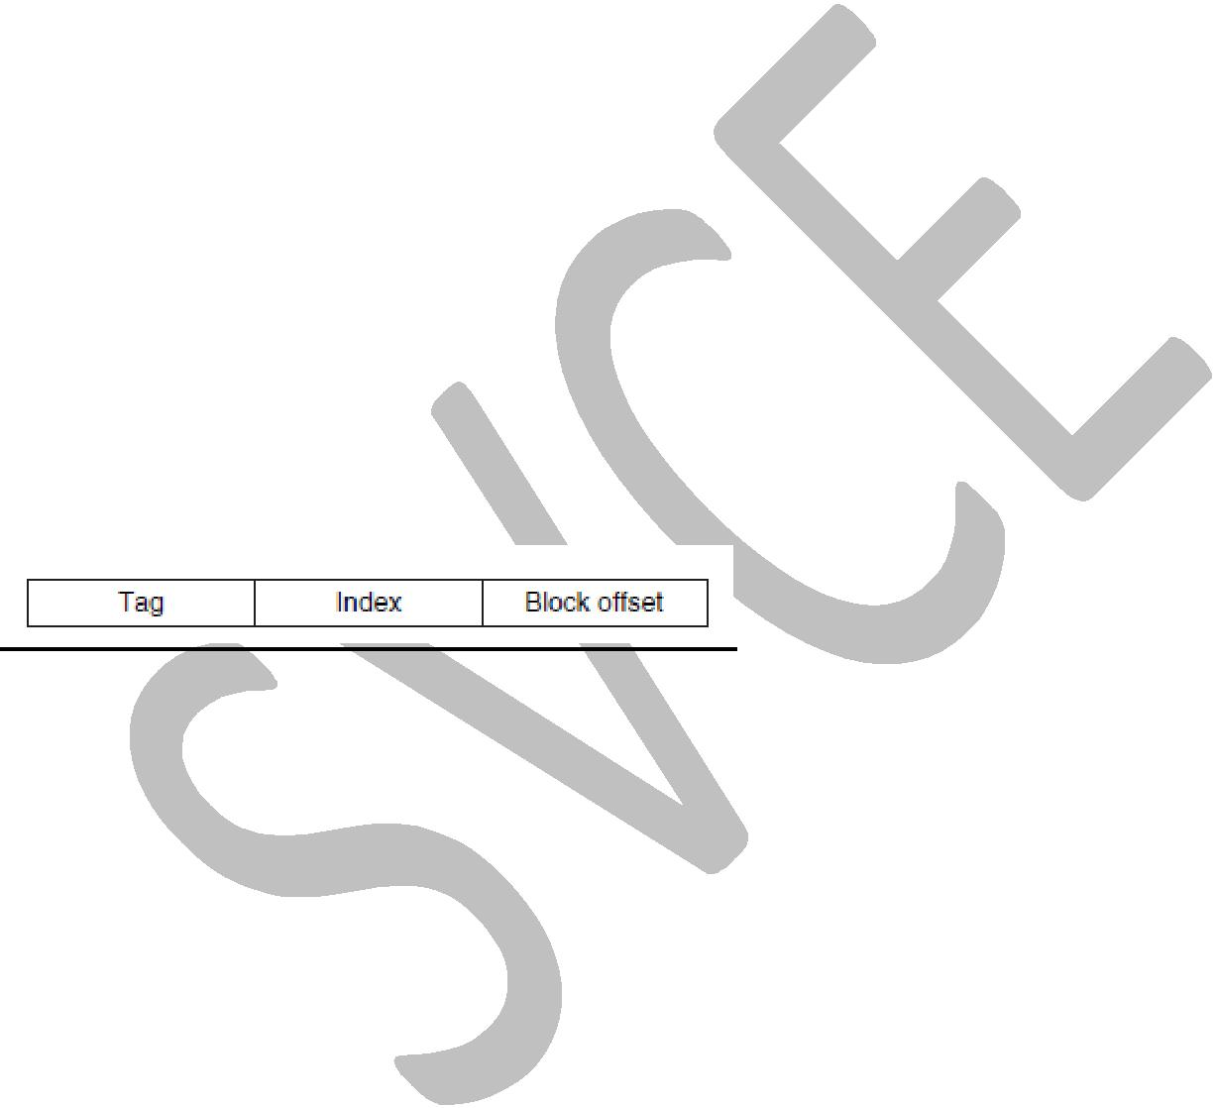
For this series of references, three misses is the best we can do, because three unique block addresses are accessed. Notice that if we had eight blocks in the cache, there would be no replacements in the two-way set-associative cache, and it would have the same number of misses as the fully associative cache. Similarly, if we had 16 blocks, all 3 caches would have the same number of misses.

LOCATING A BLOCK IN THE CACHE:

Now, let’s consider the task of finding a block in a cache that is set associative. Just as in a direct-mapped cache, each block in a set-associative cache includes an address tag that gives the block address. The tag of every cache block within the appropriate set is checked to see if it matches the block address from the processor.

The above figure decomposes the address as three portions of an address in a set-associative or direct-mapped cache. The index is used to select the set, then the tag is used to choose the block by comparison with the blocks in the selected set. The block off set is the address of the desired data within the block.

The implementation of a four-way set-associative cache:

The implementation requires four comparators and a 4-to-1 multiplexor.

The index is used to select the set out of the 256 sets (0-255). The tag is used to select the block within the selected set.

The comparators determine which element of the selected set (if any) matches the tag. The output of the comparators is used to select the data from one of the four blocks of the indexed set, using a multiplexor with a decoded select signal.

Hit - The output of the comparator and the valid bit is AND if both the values are 1 then output of the AND is 1 (i.e.) hit. If either valid bit or comparator output is 0 then it is a miss.

25
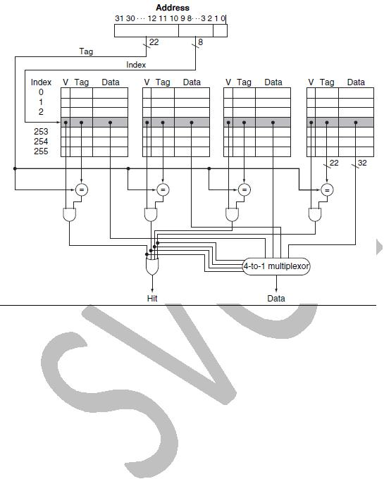

CHOOSING WHICH BLOCK TO REPLACE:

Least recently used (LRU): A replacement scheme in which the block replaced is the one that has been unused for the longest time.

When replacement is needed?

When a miss occurs in a direct-mapped cache, the requested block can go in exactly one position, and the block occupying that position must be replaced. In an associative cache, we have a choice of where to place the requested block, and hence a choice of which block to replace. In a fully associative cache, all blocks are candidates for replacement. In a set-associative cache, we must choose among the blocks in the selected set.

REDUCING THE MISS PENALTY USING MULTILEVEL CACHES

Multilevel cache - A memory hierarchy with multiple levels of caches, rather than just a cache and main memory.

All modern computers make use of caches. To close the gap further between the fast clock rates of modern processors and the increasingly long time required to access DRAMs, most microprocessors support an additional level of caching. This second-level cache is normally on the same chip and is accessed whenever a miss occurs in the primary cache. If the second-level cache contains the desired data, the miss penalty for the first-level cache will be essentially

26

the access time of the second-level cache, which will be much less than the access time of main memory. If neither the primary nor the secondary cache contains the data, a main memory access is required, and a larger miss penalty is incurred.

How significant is the performance improvement from the use of a secondary cache?

PERFORMANCE OF MULTILEVEL CACHES:

PROBLEM:

Suppose we have a processor with a base CPI of 1.0, assuming all references hit in the primary cache, and a clock rate of 4 GHz. Assume a main memory access time of 100 ns, including all the miss handling. Suppose the miss rate per instruction at the primary cache is 2%. How much faster will the processor be if we add a secondary cache that has a 5 ns access time for either a hit or a miss and is large enough to reduce the miss rate to main memory to 0.5%?

Given:
Base CPI = 1

Clock rate = 4GHz, so clock period = 1/4GHz = 0.25 ns
Main memory access time = 100ns
Primary cache miss rate per instruction = 2%
Secondary cache access time = 5ns
Secondary cache miss rate per instruction = 0.5%

Solution:

Clock cycle time or clock period = 1/clock rate = 1/4GHz = 0.25 ns

The miss penalty in terms of no. of clock cycles = Memory access time / clock cycle time

The miss penalty of main memory = 100 ns / 0.25 ns = 400 clock cycles

The effective CPI with one level of caching is given by, Total CPI = Base CPI + Memory-stall cycles per instruction

For the processor with one level of caching,
Total CPI = 1.0 + Memory-stall cycles per instruction

- 1.0 + 2% x 400
- 9

With two levels of caching, a miss in the primary (or first-level) cache can be satisfied either by the secondary cache or by main memory.

The miss penalty of second-level cache = 20 ns / 0.25 ns = 20 clock cycles

27

If the miss is satisfied in the secondary cache, then this is the entire miss penalty. If the miss needs to go to main memory, then the total miss penalty is the sum of the secondary cache access time and the main memory access time.

Thus, for a two-level cache,

Total CPI is the sum of the stall cycles from both levels of cache and the base CPI:
Total CPI = Base CPI + Primary stalls per instruction + Secondary stalls per instruction
- 1 + Primary stalls per instruction + Secondary stalls per instruction
- 1 + 2% x 20 + 0.5% x 400
- 1 + 0.4 + 2.0
- 3.4

Thus, the processor with the secondary cache is faster by
Total CPI of single-level cache / Total CPI of two-level cache = 9.0/3.4 = 2.6

VIRTUAL MEMORY:

In earlier sections, we saw how caches provided fast access to recently used portions of a program’s code and data. Similarly, the main memory can act as a “cache” for the secondary storage, usually implemented with magnetic disks. This technique is called virtual memory.

Virtual memory: A technique that uses main memory as a “cache” for secondary storage.

Physical address: An address in main memory.

Virtual address: An address that corresponds to a location in virtual space and is translated by address mapping to a physical address when memory is accessed.

Page: A virtual memory block is called a page, and a virtual memory miss is called a page fault.

Page fault: An event that occurs when an accessed page is not present in main memory.

Address translation: Also called address mapping. The process by which a virtual address is mapped to an address used to access memory.

The below figure shows the virtual memory, blocks of memory (called pages) are mapped from one set of addresses (called virtual addresses) to another set (called physical addresses). The processor generates virtual addresses while the memory is accessed using physical addresses. Both the virtual memory and the physical memory are broken into pages, so that a virtual page is mapped to a physical page. Of course, it is also possible for a virtual page to be absent from main memory and not be mapped to a physical address; in that case, the page resides on disk.

28
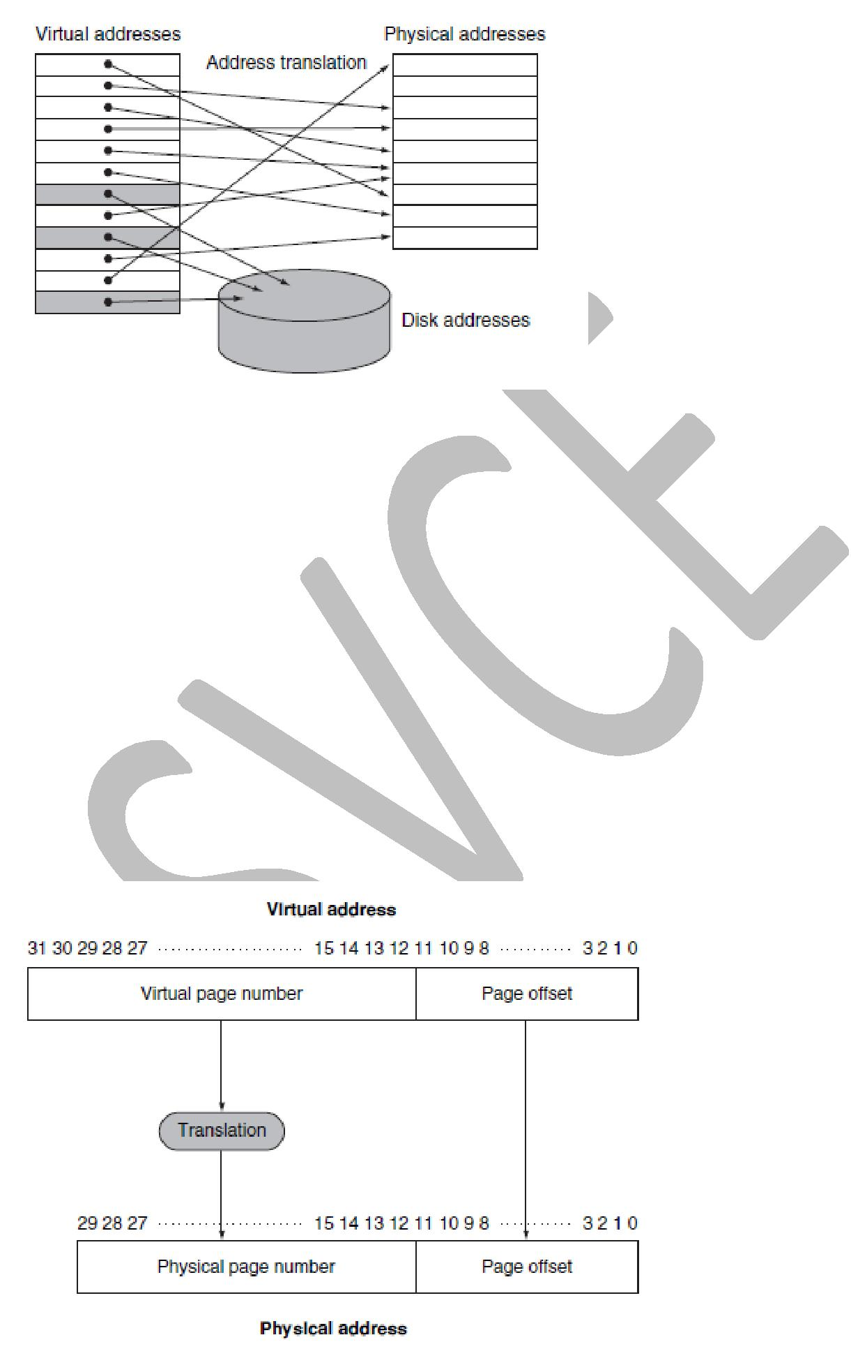

The below figure shows the translation of the virtual page number to a physical page number.

In virtual memory, the address is broken into a virtual page number and a page offset. The physical page number constitutes the upper portion of the physical address, while the page off set, which is not changed, constitutes the lower portion.

The number of bits in the page offset field determines the page size. The number of pages addressable with the virtual address need not match the number of pages addressable with the physical address. Having a larger number of virtual pages than physical pages is the basis for the illusion of an essentially unbounded amount of virtual memory.

Example:
The page size is 2¹² = 4 KiB. The number of physical pages allowed in memory is 2¹⁸, since the physical page number has 18 bits in it. Thus, main memory can have at most 1 GiB, while the virtual address space is 4 GiB.

29

Placing a Page and Finding It Again:

The page table is indexed with the virtual page number to obtain the corresponding portion of the physical address. We assume a 32-bit virtual address. The page table pointer gives the starting address of the page table. In the below figure, the page size is 2¹² bytes, or 4 KiB (since page offset is 12 bits). The virtual address space is 2³² bytes, or 4 GiB, and the physical address space is 2³⁰ bytes, which allows main memory of up to 1 GiB. The number of entries in the page table is 2²⁰, or 1 million entries. The valid bit for each entry indicates whether the mapping is legal. If it is off, then the page is not present in memory. The page table entry shown here need only be 19 bits.
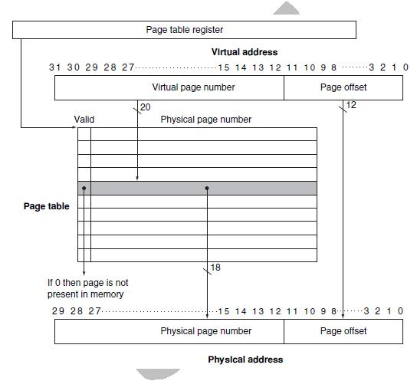

Page Faults:

The below figure shows how the page table is used in mapping each page in virtual memory to either a page in main memory or a page stored on disk, which is the next level in the hierarchy. The virtual page number is used to index the page table. If the valid bit is on, the page table supplies the physical page number (i.e., the starting address of the page in memory) corresponding to the virtual page (page hit). Page fault: If the valid bit is off, the page currently resides only on disk, at a specified disk address.

30
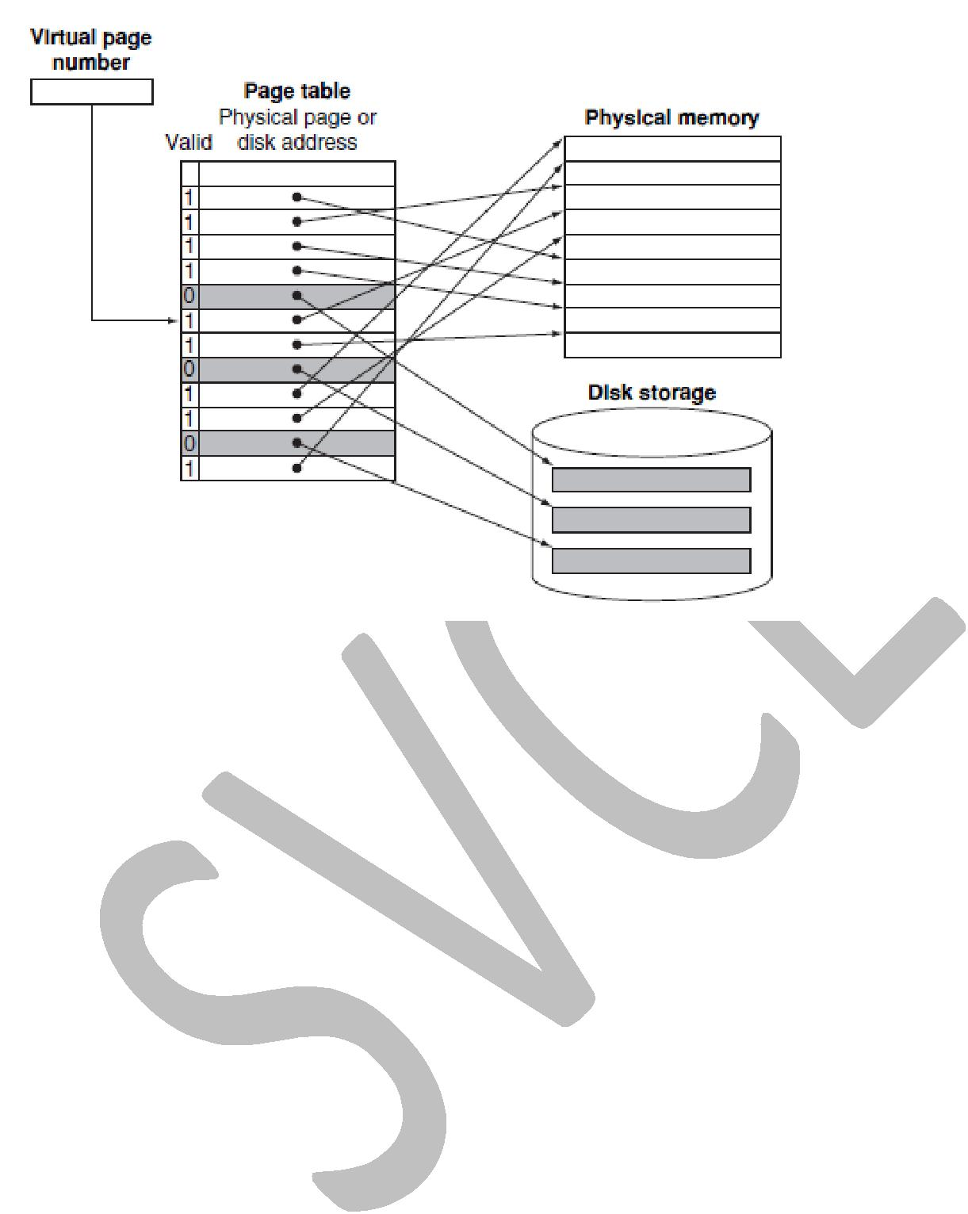

What about Writes? – handling using dirty bit:

Write-back scheme has another major advantage in a virtual memory system. Because the disk transfer time is small compared with its access time, copying back an entire page is much more efficient than writing individual words back to the disk.

sA write-back operation, although more efficient than transferring individual words, is still costly. Thus, we would like to know whether a page needs to be copied back when we choose to replace it. To track whether a page has been written since it was read into the memory, a dirty bit is added to the page table. The dirty bit is set when any word in a page is written. If the operating system chooses to replace the page, the dirty bit indicates whether the page needs to be written out before its location in memory can be given to another page. Hence, a modified page is often called a dirty page.

MAKING ADDRESS TRANSLATION FAST: THE TLB

Translation-lookaside buffer (TLB): A cache that keeps track of recently used address mappings to try to avoid an access to the page table.

The TLB acts as a cache of the page table for the entries that map to physical pages only. The below figure shows how TLB works. The TLB contains a subset of the virtual-to-physical page mappings that are in the page table. The TLB mappings are shown in color. Because the TLB is a cache, it must have a tag field. If there is no matching entry in the TLB for a page(TLB miss), the page table must be examined. The page table either supplies a physical page number for the page (which can then be used to build a TLB entry) or indicates that the page resides on disk, in which case a page fault occurs. Since the page table has an entry for every virtual page, no tag field is needed; in other words, unlike a TLB, a page table is not a cache.

31
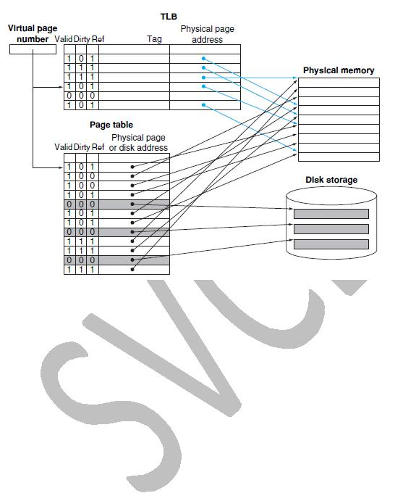

Steps:
- Virtual address is generated by the processor
- On every reference, we look up the virtual page number in the TLB.

- If we get a TLB hit, the physical page number is used to form the address, and the corresponding reference bit is turned on. If the processor is performing a write, the dirty bit is also turned on.

- If a miss in the TLB occurs, we must determine whether it is a page fault or merely a TLB miss.

- If the page exists in memory, then the TLB miss indicates only that the translation is missing. In such cases, the processor can handle the TLB miss by loading the translation from the page table into the TLB and then trying the reference again.

- If the page is not present in memory, then the TLB miss indicates a true page fault.

- Page fault is handled by bringing the corresponding page from the disk to the physical memory and updating the page table entry with physical page number, valid bit set to 1 and reference bit set to 1.

